**K-Nearest Neighbour Algorithm**

* K-Nearest Neighbour is one of the simplest Machine Learning algorithms based on Supervised Learning technique.
* K-NN algorithm assumes the similarity between the new case/data and available cases and put the new case into the category that is most similar to the available categories.
* K-NN algorithm stores all the available data and classifies a new data point based on the similarity. This means when new data appears then it can be easily classified into a well suite category by using K- NN algorithm.
* K-NN algorithm can be used for Regression as well as for Classification but mostly it is used for the Classification problems.

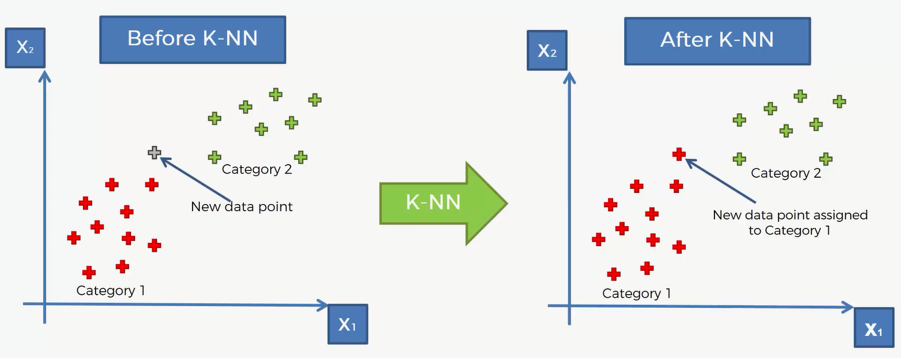

* In the above left diagram you can see 2 categories red and green.
* If the new data point is added, we have to know that in which It will get assigned to.

**How does K-NN work?**

The K-NN working can be explained on the basis of the algorithm:

* **Step-1:** Select the number K of the neighbors.

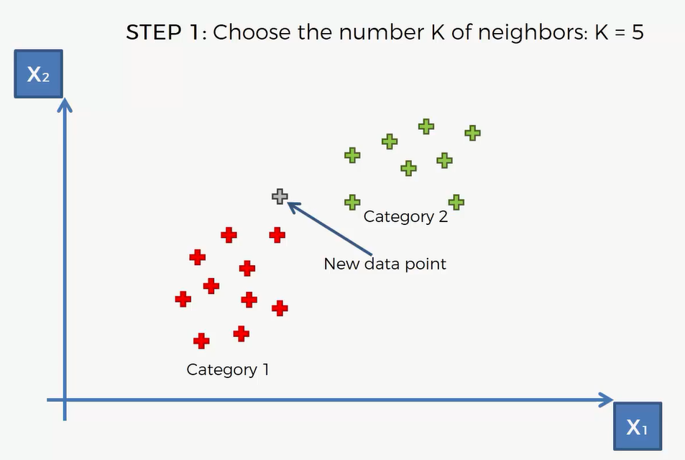

**Step-2:** Calculate the Euclidean distance of **K number of neighbors**

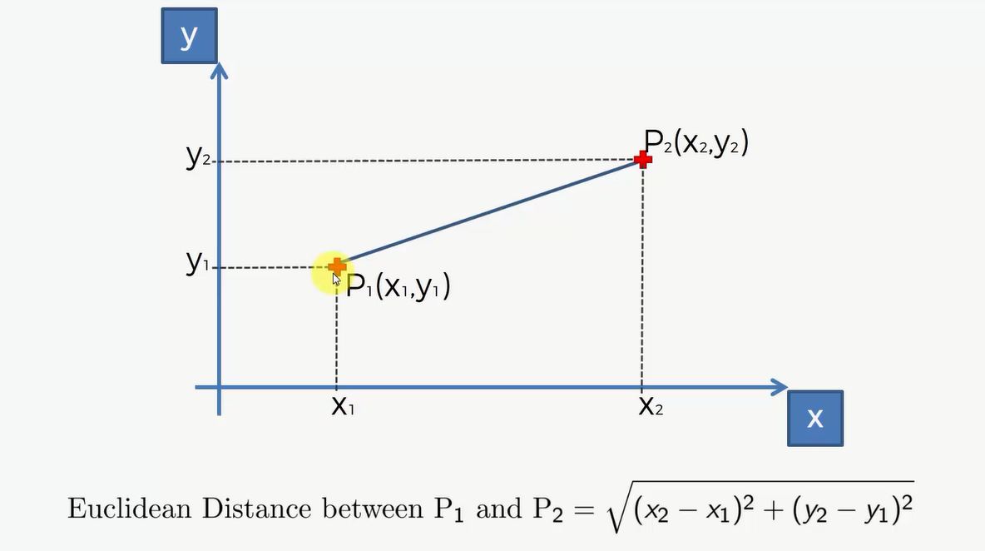

* **Step-:** Take the K nearest neighbors as per the calculated Euclidean distance.

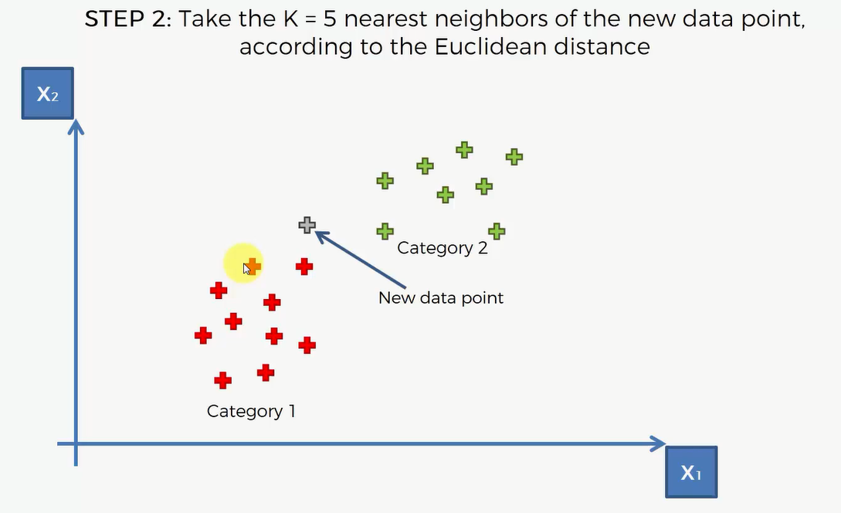

* **Step-3:** Among these k neighbors, count the number of the data points in each category.

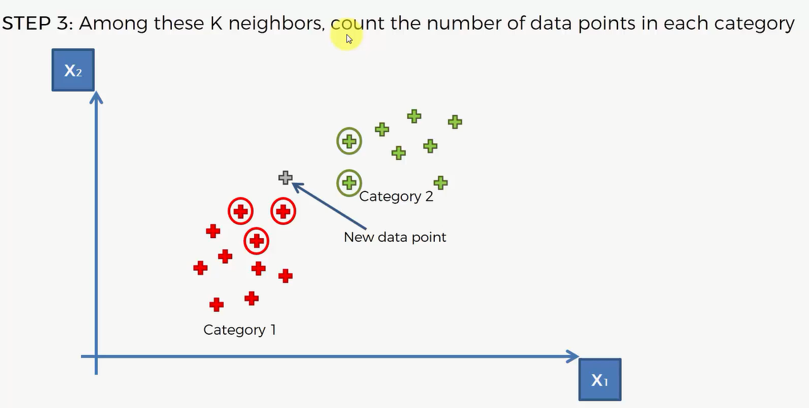

* **Step-4:** Assign the new data points to that category for which the number of the neighbor is maximum.
* **Step-5:** Our model is ready.

